Test preparation or curriculum implementation: Persuasive writing to value student voice
Joanne Rossbridge

Teaching Resources Writing Feb 14, 2023
As the new school year begins and teachers are faced with NAPLAN occurring earlier than in previous years, we start to play the guessing game of what type of text students will be required to write. The bets on persuasive or imaginative writing have already started!
Carter (2017) discusses how ‘attention is effectively diverted from curriculum implementation’ through the emphasis on systemic testing. If your bets are on a particular type of writing, it is easy to succumb to the pressure, however, it is also a chance to embrace and use the situation to not only prepare for the test but more importantly focus on rich, engaging curriculum implementation by embedding your writing focus into not only English but also other subject area units.
As with any focus on writing, the most important aspect when planning is to consider the context for writing. The more authentic and meaningful, the better for engaging students. Who would want to write a persuasive text if there is no one to persuade and no possibility of a response or outcome? In preparation for systemic tests, it is understandable how we can fall into the trap of formulaic and clinical writing on the same old topics such as dogs are better than cats, we should or shouldn’t wear school uniform or animals shouldn’t be kept in cages. These texts are often written with an examiner as the audience in mind and don't show the importance of persuasion within our culture.
Before planning, it is always worth refreshing definitions of what we mean by persuasive texts. Curriculum documents are one place to look. In the Glossary of the NSW Curriculum, it states that a persuasive text is:
A text designed to convince a reader of a particular opinion or way of thinking on an issue. A persuasive text may express an opinion while discussing, analysing and/or evaluating an issue. (NESA, 2022)
The Australian Curriculum goes deeper with:
Persuasive texts – their primary purpose is to put forward a point of view and persuade a reader, viewer or listener. They form a significant part of modern communication in both print and digital environments. They include advertising, debates, arguments, discussions, polemics and influential essays and articles. (ACARA, 2022)
ACARA acknowledges that persuasive texts are not only written, but they can take many forms or modes within our culture.
In every school context there is a classroom, school or community-based issue that warrants developing a stance or range of opinions. If we can have meaningful contexts for writing from the beginning of the school year, we can establish a culture where student voices are valued, and literacy is a tool for operating in not only the school but the broader culture. After all, students living in a democratic society, need to interact with friends and family and the broader community in negotiating points of view and discussing issues.
When supporting students to write persuasive texts, often we are focusing on hortatory expositions where students may have a particular audience in mind and attempt to persuade them to take action in a certain way. Analytical expositions persuade an audience to a particular point of view but not necessarily to take action. These often occur in more academic essay writing as students move into secondary school. Students might also write discussion texts where two or more perspectives are discussed before balancing the arguments with a recommendation. See Derewianka and Jones (2023) and Humphrey, Droga and Feez (2012 ) for examples and further explanation. For greatest student engagement, hortatory expositions can lead to exchanges between writer and audience and actions in response to texts.
Planning for teaching writing in meaningful contexts requires consideration of the following:
- Would and where might such a text occur in the school or broader context?
- What does the issue mean to students personally?
- Do students have relevant background knowledge to take a stance?
- Can the issue be considered by a particular audience or stakeholder?
- Is the audience a particular person or a group or organisation?
- Does the audience have the power to make changes?
- Has the student as writer and the audience ever met or interacted in any way?
- How aligned are the values and beliefs of the audience with those of the students?
- Where and how will the text be shared or published?
- How will this knowledge about context and audience in particular influence the language choices?
These are also questions we can discuss with students.
To motivate students to write persuasively, opportunities arise at times that might ignite interest or passion in students. For example, Taronga Zoo often has competitions to name baby animals. This tends to require coming up with or selecting a name and writing a short response to give reasons for the choice of name. Opportunities exist for class surveys and voting and creation of graphs prior to writing either individual or class responses.
Beginning in 2022, the Sun Project: Shadow judging, gives children the opportunity to judge the Children’s Book Council of Australia shortlisted books for Book Week. The theme of the project is ‘Young voices are welcome here’. Young readers get to express their opinions and share their responses as judges, ‘shadowing’ the CBCA judges. They use the CBCA Book of the Year Awards criteria to reflect on literary values and to communicate their choices to share with the wider community. Reviewing texts requires language of persuasion and evaluation and the Sun Project provides an authentic, meaningful context for communicating opinions.
Topics will obviously become less familiar and more complex as students move through schooling. At the same time audiences for writing also become less familiar as students engage with more complex topics and issues. This familiarity and complexity of content is captured in the content of subjects such as but not limited to Geography, Science and Technology, and Personal Development and Health.
The context for some of the topics and audiences below can be developed based on particular subject area content in order to create meaningful curriculum contexts for writing. By considering different contexts and audiences when persuading, we can explicitly discuss language choices appropriate to the situation. Students can match topics and audiences in the table below or add their own topics and audiences. If considered in relation to cross curriculum content these topics and audiences can be further refined.
As stated, many of these topics can be linked to cross curriculum areas so that student arguments are based on relevant and well-developed field knowledge. This also means we can easily make meaningful connections between reading and writing when planning and programming. Obviously, the choice of context and topic will depend on the interests and age of students but giving voice through planning for students to write in authentic contexts is an important way to begin a new school year and develop student voice as part of the classroom culture.
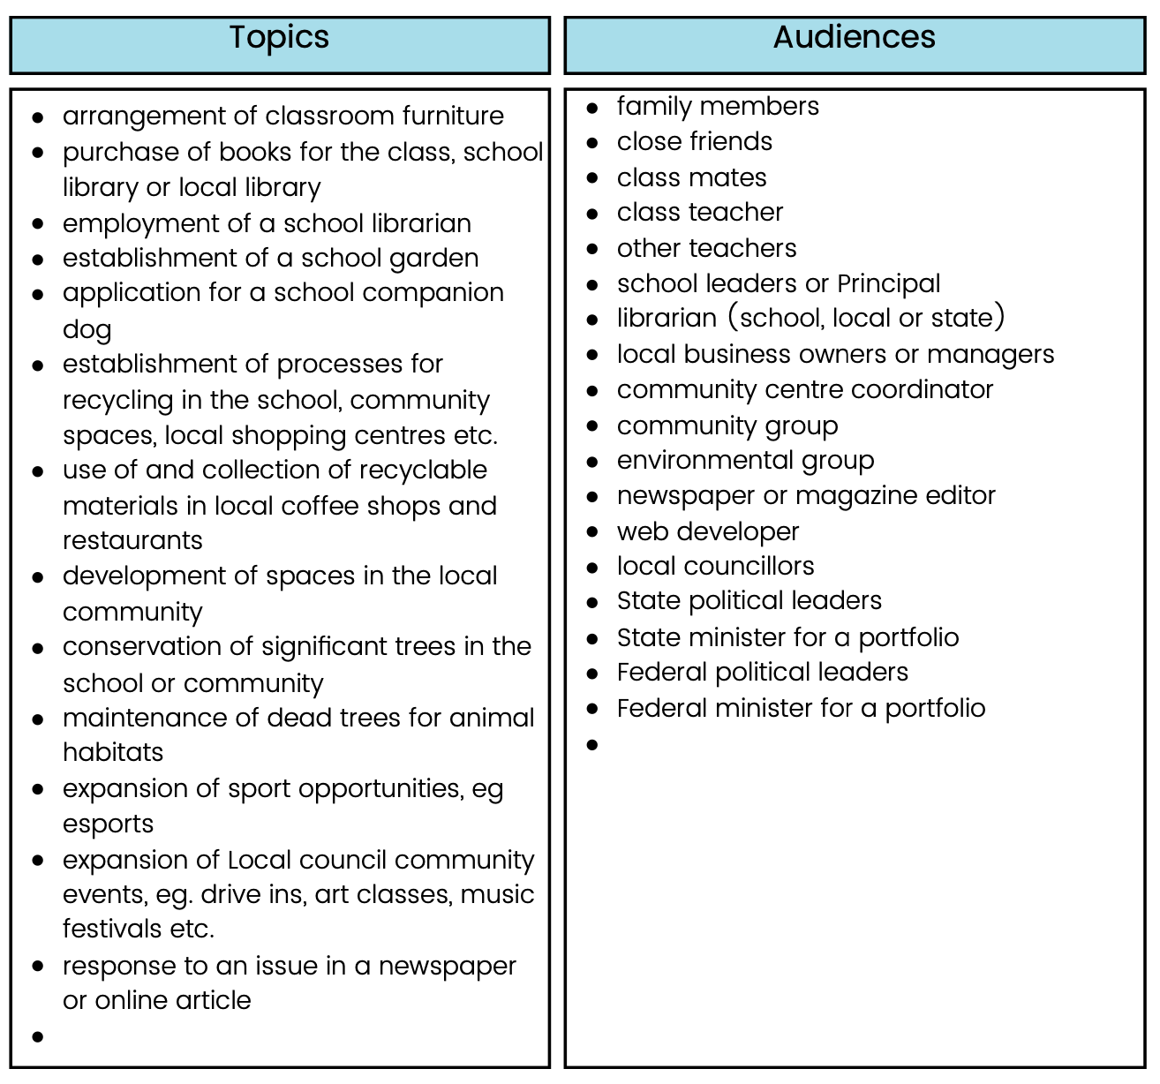

References
Carter, D. (2017). The dark side of NAPLAN: it’s not just a benign ‘snapshot’. Eduresearch Matters: Australian Association for Research in Education https://www.aare.edu.au/blog/?p=2325
Derewianka, B. & Jones, P. (2023) Teaching Language in Context. (3rd Ed.) Oxford.
Humphrey, S., Droga, L., & Feez, S. (2012) Grammar and Meaning. PETAA.

